Optimize utilization of a web application (café web application)

Connect to the web server and the host

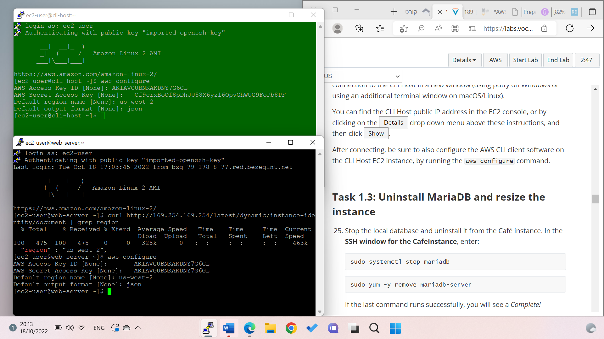

Then uninstall MariaDB to resize the instance

Stopping the instance and changing it to t3.micro

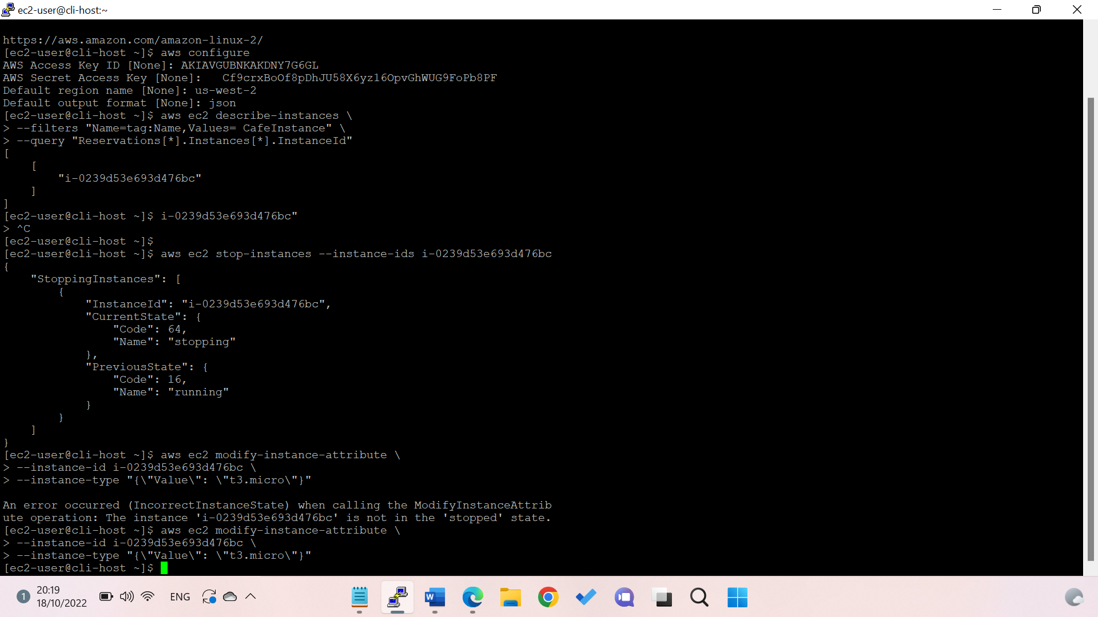start the instance again and check if its "running"

Making sure that the DNS works

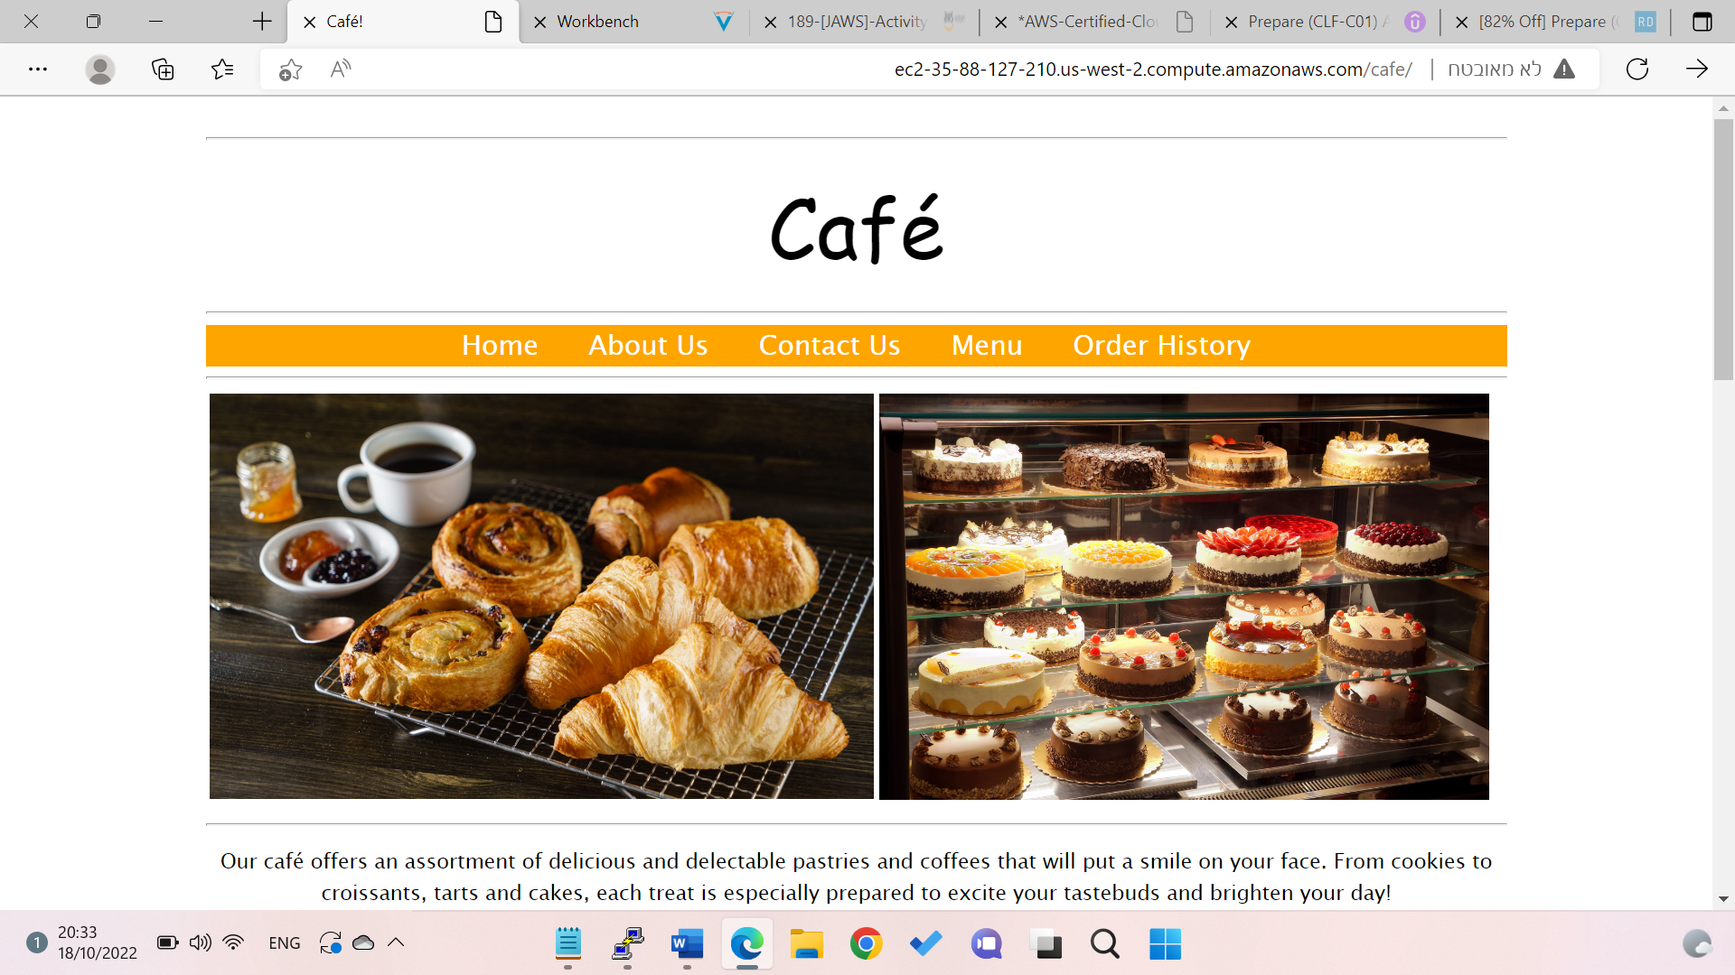

Calcaluting how much costs the EC2 before optimizing it and reducing cost\

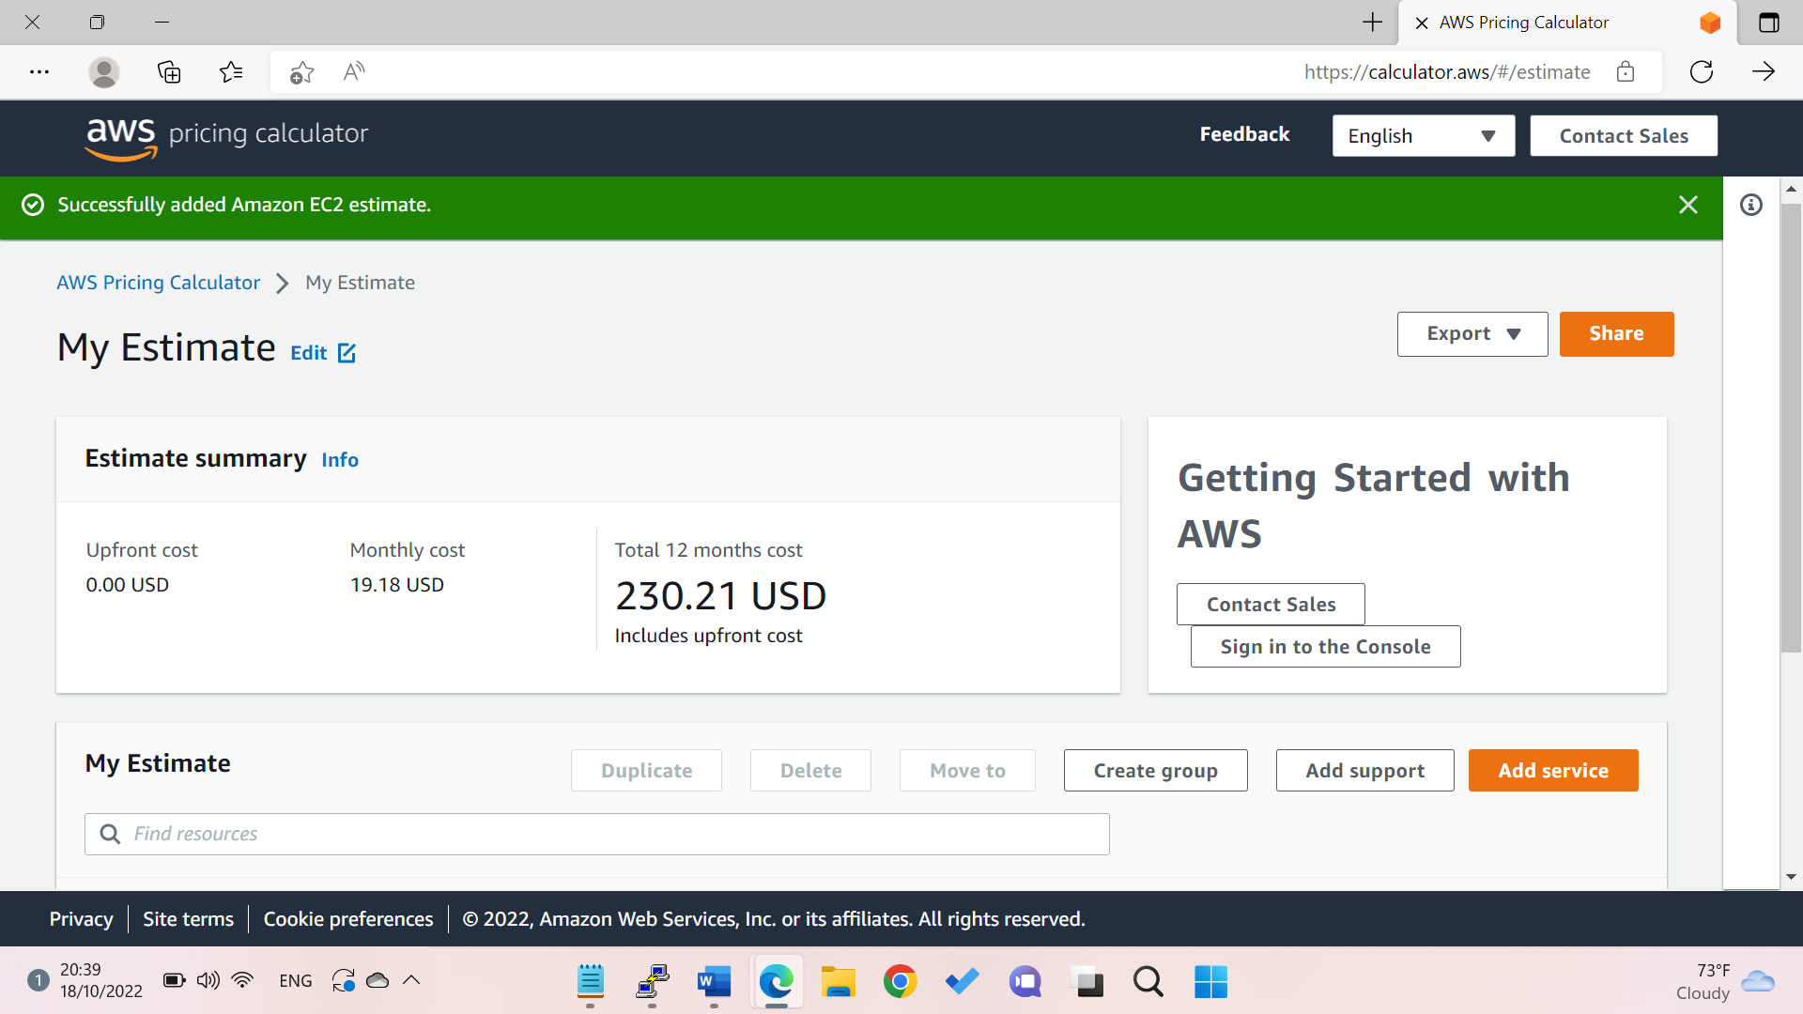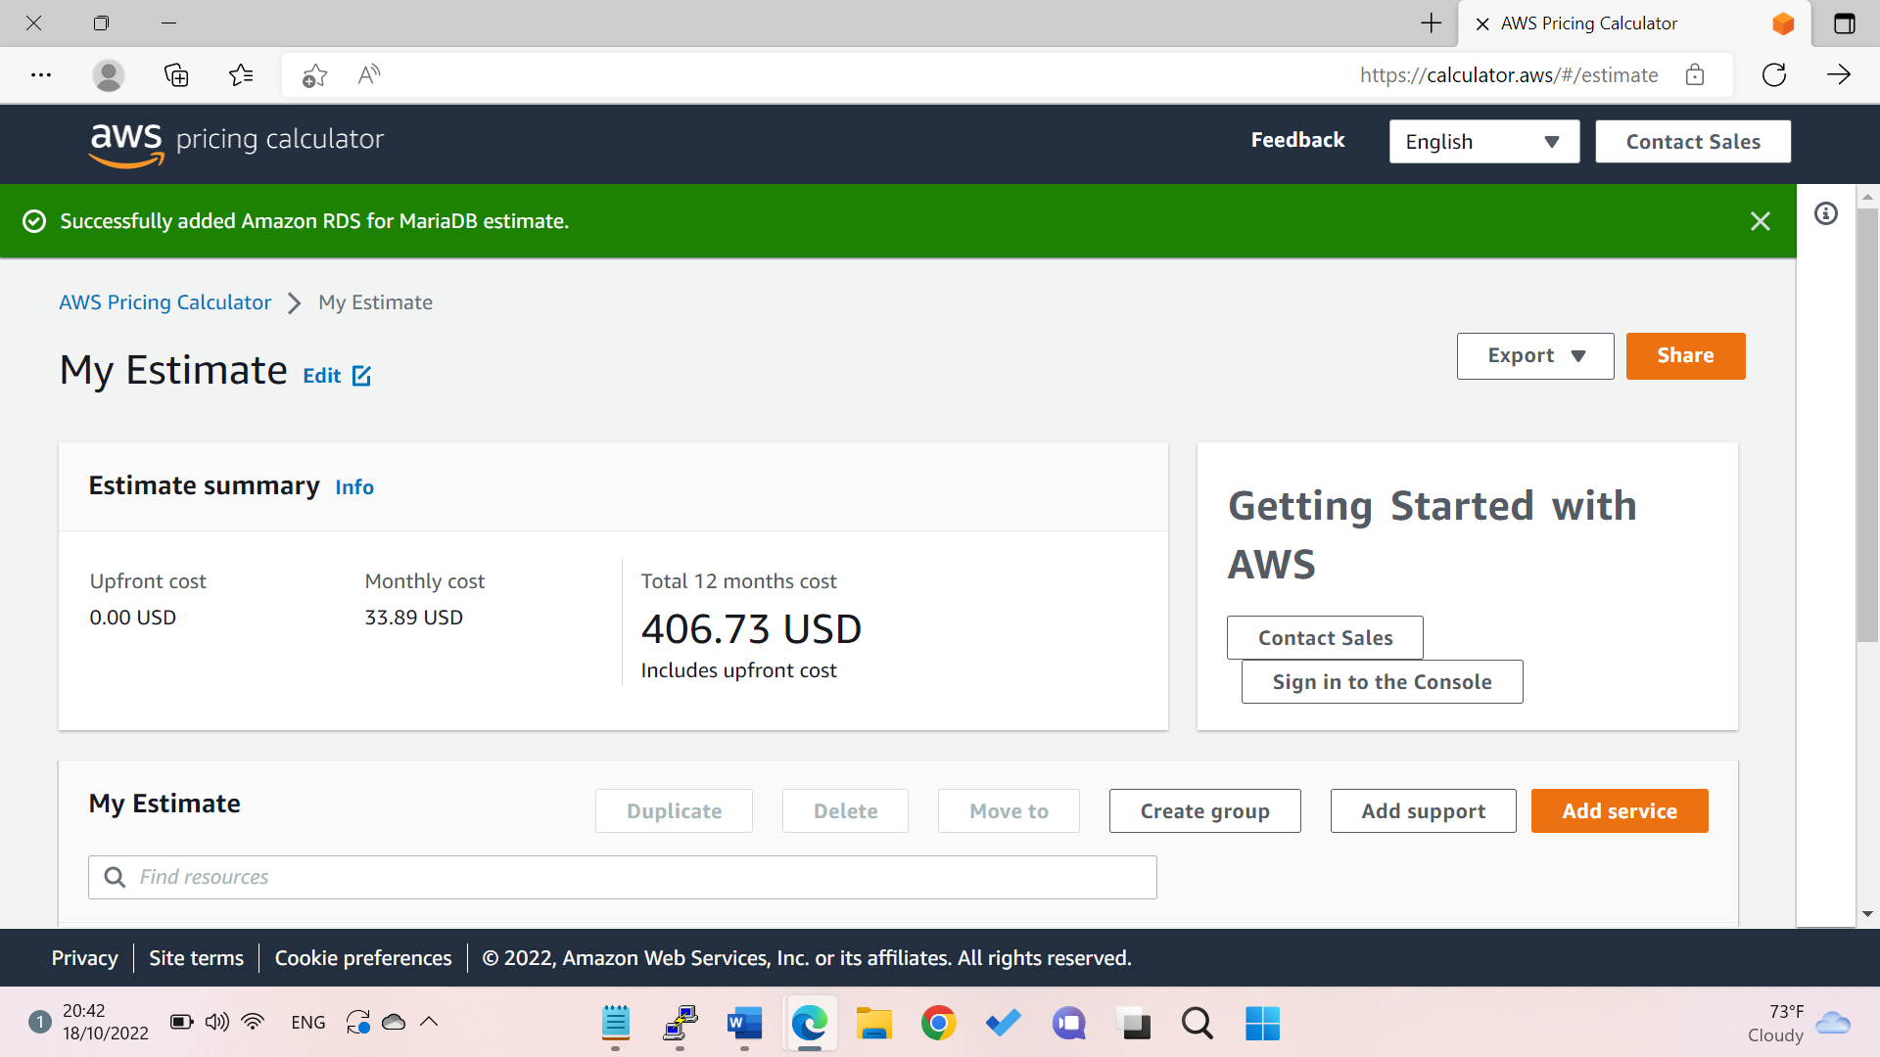

Download the estimate as a CSV file



